Barometer

Humidity measurement

Level measurement

## Barometer

**[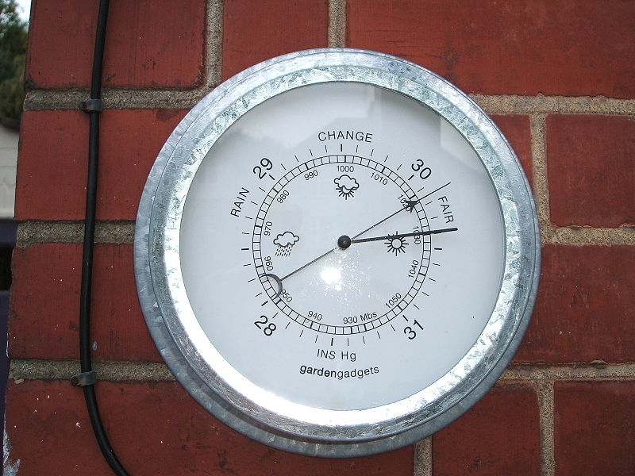](https://climate.ncsu.edu/images/edu/Barometer.JPG)**  
Figure . Modern Aneroid Barometer.

Atmospheric pressure is measured by barometers.  An aneroid barometer, one of the most common types, uses a sealed can of air to detect changes in atmospheric pressure.  As the atmospheric pressure goes up, it pushes in on the can, and the can is slightly reduced in volume, moving an indicator needle towards higher pressure.  If the atmospheric pressure goes down, the can expands slightly and the needle indicates lower pressure.  Some barometers in the past used special graph paper to track changing pressure over time; now, they report electronic signals to a computer, which plots the trends of pressure on computer monitors.

**Humidity measurement**

[**Hygrometer**](https://climate.ncsu.edu/images/edu/anemometer2.jpg)

**[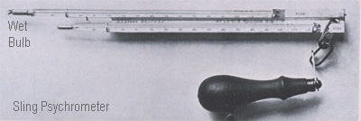](https://climate.ncsu.edu/images/edu/psychrometer.jpg)**  
. Sling psychrometer. (Image from NASA).

A hygrometer is an instrument used to measure relative humidity.  Humidity is the measure of the amount of moisture in the air.  A psychrometer is an example of a hygrometer.  A psychrometer uses two thermometers to measure relative humidity; one measures the dry-bulb temperature and the other measures the wet-bulb temperature. (When you come out of your shower in the morning, your skin cools to the wet-bulb temperature and you feel a chill until the water evaporates.)  The wet-bulb thermometer contains water in the base that evaporates and absorbs heat which decreases the temperature reading. To determine the relative humidity, the temperatures are taken from the dry-bulb thermometer and the temperature difference between the wet and dry bulb thermometers. From these measurements, a table is used to find the relative humidity at a certain location. A sling psychrometer is a common instrument used by meteorologists to determine the relative humidity. This instrument is swung around while being held.  There are also a variety of other humidity sensors which work automatically to measure the water content and relative humidity of the atmosphere.

**Hair hygrometer**

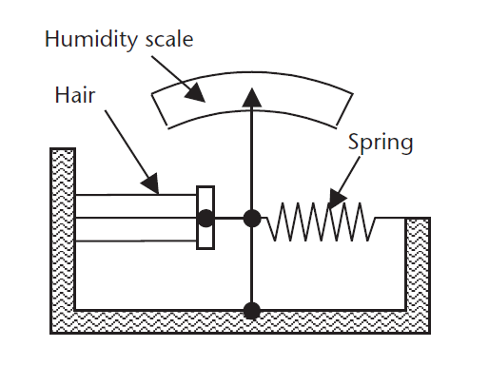

### Principle of Hair hygrometer

Due to humidity, several materials undergo a change in physical, chemical and electrical properties. This property is used in a transducer designed and calibrated to directly read the relative humidity.

Certain hygroscopic materials, such as human hair, animal membranes, wood, paper, etc., undergo changes in the linear dimensions when they absorb moisture from the surrounding air. This change in the linear dimension is used as the measurement of the humidity present in the air.

### Construction of Hair hygrometer

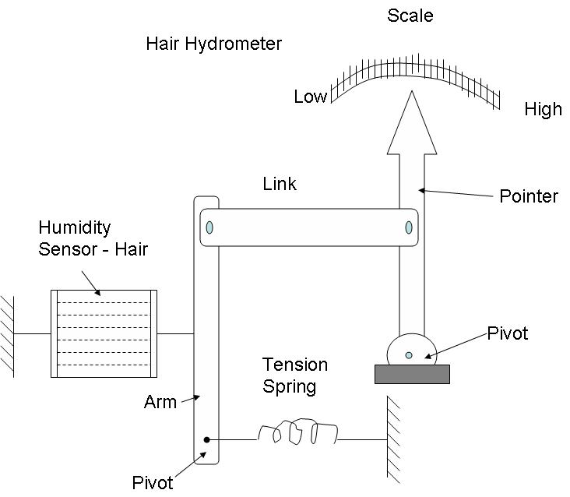

Human hair is used as a humidity sensor. The hair is arranged on a parallel beam and separated from each other to expose them to the surrounding air / atmosphere. Number of hairs are placed in parallel to increase the mechanical strength.

This hair arrangement is placed under a small tension by the use of a tension spring to ensure proper functioning.

The hair arrangement is connected to an arm and a link arrangement and the link is attached to a pointer rotated at one end. The pointer sweeps over a calibrated scale of humidity

### Working of hair hygrometer:

When air humidity is to be measured, this air is made to surround the hair arrangement and the hair arrangement absorbs moisture from the surrounding air and expands or contracts in the linear direction.

This expansion or contraction of the hair arrangement moves the arm and the link and, therefore, the pointer to a suitable position on the calibrated scale and, therefore, indicates the humidity present in the air / atmosphere.

### Application of Hair hygrometer

* These hydrometers are used in the temperature range of 0’C to 75’C.
* These hydrometers are used in the range of relative humidity (relative humidity) from 30 to 95%.
* Limitations of the hydrometer for the hair
* These hydrometers are slow in response
* If the hair hydrometer is used constantly, its calibration tends to change.

LEVEL measurement

Level instrumentation includes a range of level measurement equipment including switches, controllers, transducers and radars. These instruments play a vital role in ensuring silos, tanks and vessels maintain levels that are within safe operating limits.

here are two level instrument types: point level and continuous level. [Point level instrumentation](https://www.branom.com/instruments-type-level-point.html) is used to detect variations in dry and liquid levels in silos, tanks and vessels and often incorporate the use of sensors alarms to indicate a low or high condition. [Continuous level instrumentation](https://www.branom.com/instruments-type-level-continuous.html) is used for similar purposes except it provides continuous measurement of levels within a silo, tank or vessel.

* **Capacitance Probe Switches**: Point level switches that detect high and low levels of solids and liquids in tanks, bins and silos. The switches feature two electrodes and use the fluid within the container as a dielectric. Fluid levels are determined by measuring changes in the capacitance value.
* **Mechanical Floats**: This includes point level measurement solutions such as spheres, balls and oblong objects that are buoyant in liquid and serve as visual indicators for level measurement applications. They can be solid or hollow and are made from either plastic or corrosion-resistance stainless steel.

### c. Chain or Float Gauge

The visual means of level measurement previously discussed are rivaled in simplicity and dependability by float type measurement devices. Many forms of float type instruments are available, but each uses the principle of a buoyant element that floats on the surface of the liquid and changes position as the liquid level varies.

Many methods have been used to give an indication of level from a float position with the most common being a float and cable arrangement. The operational concept of a float and cable is shown in the following diagram;

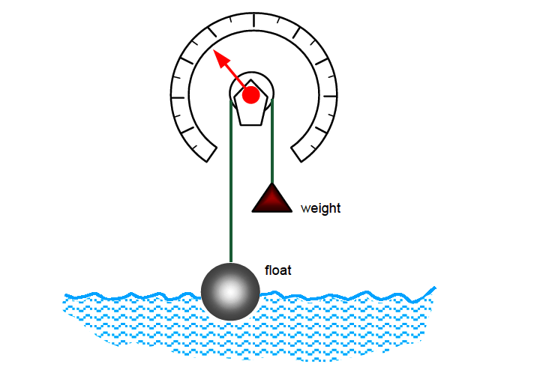

The float is connected to a pulley by a chain or a flexible cable and the rotating member of the pulley is in turn connected to an indicating device with measurement graduation. As can be seen, as the float moves upward, the counterweight keeps the cable tight and the indicator moves along the circular scale.

* **Ultrasonic**: This type of level measurement transmitter uses high-frequency sound to detect product levels. The transmitter is placed at the top of a tank and transmits ultrasonic pulses that are reflected off the surface of the product. The sensor then creates a measurement calculation based off the signal. Ultrasonic transmitters are used for continuous level measurement.
* **Vibrating Tuning Fork Switches**: These point level measurement switches are installed in pipes and vessels to detect high and low fluid level and prevent overflow. The switches contain two prongs that vibrate at a natural frequency until they become immersed in the product, which causes the frequency to drop. These changes are monitored by sensors that can be programmed to trigger an alarm or valve once a certain level is reached.
* **Guided Wave Radar**: These continuous level controllers use radar to measure levels of fluids and dry media.  The radar level control equipment features a probe that is immersed in the liquid or dry media and sends low energy pulses down the probe. The energy then reflects up the probe and provides the measurement between the surface of the media and the top of the storage vessel.