IIC
- Pressure measuring devices
- Speed measuring devises
Pressure Measuring devices
Different pressure
Definitions:
The pressure is defined as the force acting per unit area. Following are the different types of pressure based on the reference pressure:
- Absolute pressure: Pressure which is related to reference pressure is known as absolute pressure.
- Differential pressure: The difference between the two pressures is equal to the differential pressure.
- Atmospheric pressure: Pressure related to the atmosphere that surrounds the earth is atmospheric pressure. This pressure is weather-dependent.
- Gauge pressure: This is the difference between absolute pressure and atmospheric pressure.

Manometer
- Manometer is also called a liquid column manometer and is used for low differential pressure measurement. The usual range of pressure that falls for this device is around 0.2 MPa or 2 Kg/cm2. This device is used for most cases as it is very simple in construction and highly accurate of all the types.
- There are basically two types of manometers.
- U-Tube Manometer
- Well Type Manometer
- There are also variations of the above said basic types called Enlarged-Leg Type Manometer, and Inclined Tube Manometer. Another manometer used commercially is the Ring-Balance Type Manometer.
- U-Tube Manometer
- A simple u-tube manometer is shown below. If ‘dm‘is the manometric fluid density, ‘d1’ is the density of the fluid over the manometer, ‘P2’ is the atmospheric pressure (for general measurement of gas pressure) and ‘P1’ is the gas pressure, and also if d1<<dm, then the differential pressure can be obtained by the relation:
p1-p2 = h (dm-d1)
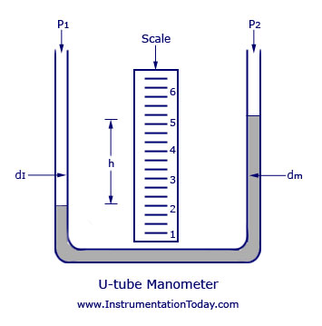

Well-Type Manometer
The main difference between a U-tube manometer and a well type manometer is that the U-tube is substituted by a large well such that the variation in the level in the well will be negligible and instead of measuring a differential height, a single height in the remaining column is measured. If a1 and a2 are the areas of the well and the capillary, and if (h1-h2) is the difference in height in the well due to the pressure difference (p1-p2) as shown, at balance, then
p1-p2 = dm.h (1+a2/a1)
The figure of a well-type manometer is shown below.
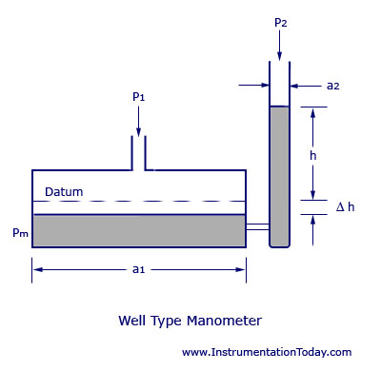
Inclined Tube Manometer
The inclined tube manometer is an enlarged leg manometer with its measuring leg inclined to the vertical axis by an angle b. This is done to expand the scale and thereby to increase the sensitivity. The differential pressure can be written by the equation,
p1-p2 = dm.h.Cosb (1+a2/a1)
The factor cosb expands the scale of the instrument. When b is quite large, h can be increased such that (h.cosb) remains constant. The figure of an inclined tube manometer is shown below.
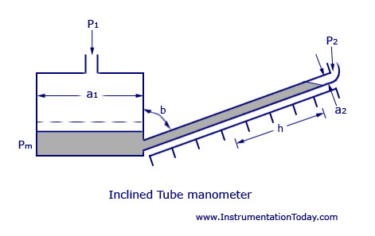

2.Elastic sensing elements
A bourdon tube is a curved, hollow tube with the process pressure applied to the fluid in the tube.
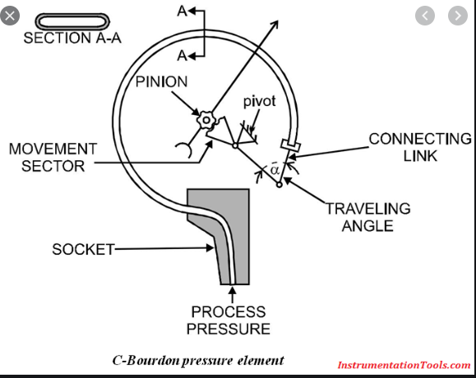
The Bourdon tube, dating from the mid nineteenth century, is still the commonest pressure indicating device. The tube is manufactured by flattening a circular cross-section tube to the section shown on Figure1 and bending it into a C shape. One end is fixed and connected to the pressure to be measured. The other end is closed and left free.

Measurement of speed

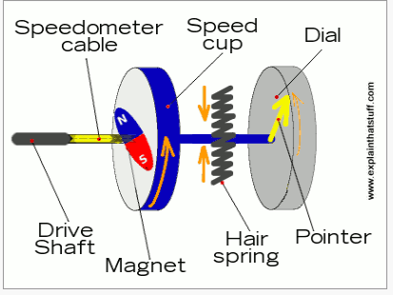

How does it all work? As the speedometer cable rotates, it turns the magnet at the same speed. The spinning magnet creates a fluctuating magnetic field inside the speed cup and, by the laws of electromagnetism, that means electric currents flow inside the cup as well. In effect, the speed cup turns into a kind of electricity generator. But, unlike in a proper generator (the kind that makes electricity for your home in a power plant), the currents in the speed cup have nowhere to go: there's nothing to carry their power away. So the currents just swim about uselessly in swirling eddies

Tachometer: The tachometer use for measuring the rotational speed or angular velocity of the machine which is coupled to it. It works on the principle of relative motion between the magnetic field and shaft of the coupled device. The relative motion induces the EMF in the coil which is placed between the constant magnetic field of the permanent magnet. The develops EMF is directly proportional to the speed of the shaft.
Depends on the natures of the induced voltage the electrical tachometer is categorized into two types.
- AC Tachometer Generator
- DC Tachometer Generator

DC Tachometer Generator
Permanent magnet, armature, commutator, brushes, variable resistor, and the moving coil voltmeter are the main parts of the DC tachometer generator. The machine whose speed is to be measured is coupled with the shaft of the DC tachometer generator.
The DC tachometer works on the principle that when the closed conductor moves in the magnetic field, EMF induces in the conductor. The magnitude of the induces emf depends on the flux link with the conductor and the speed of the shaft.
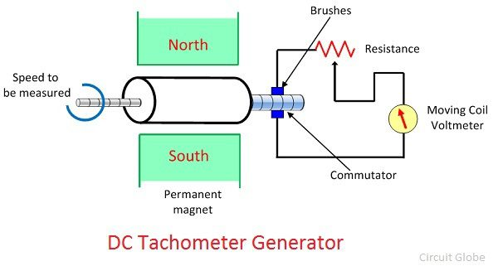The armature of the DC generator revolves between the constant field of the permanent magnet. The rotation induces the emf in the coil. The magnitude of the induced emf is proportional to the shaft speed.
The commutator converts the alternating current of the armature coil to the direct current with the help of the brushes. The moving coil voltmeter measures the induced emf. The polarity of the induces voltage determines the direction of motion of the shaft. The resistance is connected in series with the voltmeter for controlling the heavy current of the armature.
The emf induces in the dc tachometer generator is given as
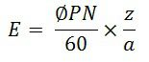Where, E – generated voltage
Φ – flux per poles in Weber
P- number of poles
N – speed in revolution per minutes
Z – the number of the conductor in armature windings.
a – number of the parallel path in the armature windings.

AC Tachometer Generator
The DC tachometer generator uses the commutator and brushes which have many disadvantages. The AC tachometer generator designs for reducing the problems. The AC tachometer has stationary armature and rotating magnetic field. Thus, the commutator and brushes are absent in AC tachometer generator.
The rotating magnetic field induces the EMF in the stationary coil of the stator. The amplitude and frequency of the induced emf are equivalent to the speed of the shaft. Thus, either amplitude or frequency is used for measuring the angular velocity.
The below mention circuit is used for measuring the speed of the rotor by considering the amplitude of the induced voltage. The induces voltages are rectified and then passes to the capacitor filter for smoothening the ripples of rectified voltages.
