PH meter
Force measuring devices
PH METER
The pH is formed from quantitative information expressed by the level of acidity or base associated with the activity of hydrogen ions.
If the concentration [H +] is greater than [OH-], then the material is acidic, i.e. the pH value is less than 7. If the concentration of [OH-] is greater than [H +], then the material is alkaline, with a pH value greater than 7.

pH meter:
The pH measurement system has three parts, namely the pH measurement electrode, the reference electrode, and the high impedance measuring device
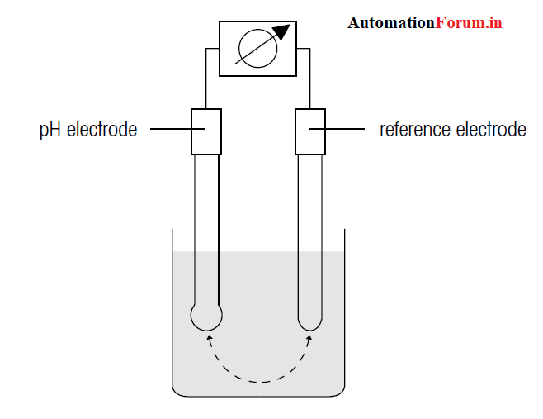
PH meter (pH electrode) is an electronic instrument used for measuring pH (acidity) of a solution (although it can also be used for semi-solid pH measurement ).

pH measurement principle
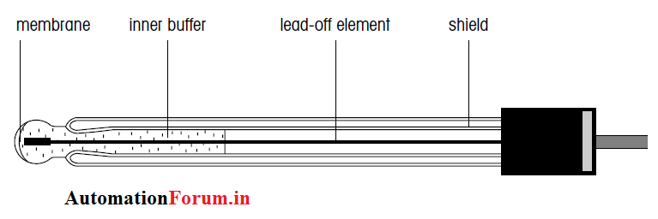
The measurement of a pH is based on the electro chemical potential that occurs between solutions found in glass electrodes (glass membranes) which have been known to dissolve which exist outside unknown glass electrodes
This is because a thin layer of glass bubbles will interact with hydrogen which is relatively small in size and active, the electrode will measure the electrochemical potential of hydrogen ions or term with the potential of hydrogen.

pH meter working:
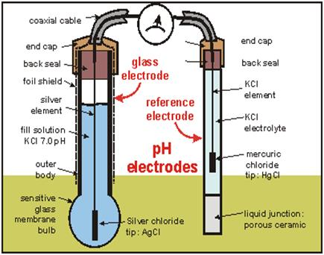
The pH meter will measure the electrical potential (in a clockwise flow image) between mercury chloride (HgCl) on the electrodes of comparison and potassium chloride (KCl) which is dissolved in the glass electrode and the potential between the solution.
The glass electrode consists of a sturdy glass tube which is connected with a thin glass bubble. Inside there is a KCl solution as a pH buffer. The tip of the silver electrode is silver chloride (AgCl2) connected to the solution
To minimize the electric effect that is not desired, the tool is protected by a layer of protective paper which is usually found in glass electrodes.
In most modern pH meters it is equipped with temperature thermistor which is a tool to correct temperature influences. Between the comparative electrodes and the gel electrodes are arranged in one unit.

LOAD CELL
A load cell is a type of transducer, specifically a force transducer. It converts a force such as tension, compression, pressure, or torque into an electrical signal that can be measured and standardized. As the force applied to the load cell increases, the electrical signal changes proportionally. The most common types of load cell used are hydraulic, pneumatic, and strain gauge.
A strain gauge is constructed of very fine wire, or foil, set up in a grid pattern and attached to a flexible backing. When the shape of the strain gauge is altered, a change in its electrical resistance occurs. Since the change in resistance measured by a single strain gauge is extremely small, it is difficult to accurately measure changes. Increasing the number of strain gauges applied collectively magnifies these small changes into something more measurable. A set of 4 strain gauges set in a specific circuit is called Wheatstone bridge.
Wheatstone Bridge
A Wheatstone bridge is a configuration of four balanced resistors with a known excitation voltage applied as shown below:
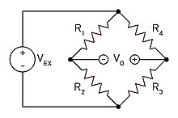
Excitation voltage is a known constant and output voltage is variable depending on the shape of the strain gauges. If all resistors are balanced, meaning then is zero. If the resistance in even one of the resistors changes, then will likewise change. The change in can be measured and interpreted using Ohm's law. Ohm's law states that the current (, measured in amperes) running through a conductor between two points is directly proportional to the voltage across the two points. Resistance (, measured in Ohms) is introduced as the constant in this relationship, independent of the current.
In a load cell, the resistors are replaced with strain gauges and arranged in alternating tension and compression formation. When force is exerted on the load cell, the structure and resistance of the strain gauges changes and is measured.

Common types of load cells[edit]
There are several types of strain gauge load cells:
- Bending beam: uses strain gauges to monitor the stress in the sensing element when spring element is subjected to a bending forces.^{[2]}
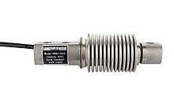
HBBG bending beam load cell (bellows type)
- Pancake: low-profile load cells often used in vessel weighing; can be tension or compression.
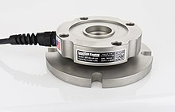
Pancake load cell (tension and compression type)
- Single point shear beam load cell: spring element fixed at one end and loaded on the other.
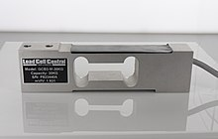
Single ended shear beam load cell
- Double-ended shear beam: spring element fixed at both ends and loaded in the center.
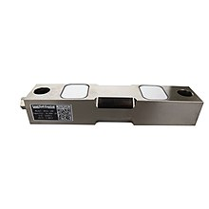
Double-ended beam load cell
- Canister load cell: Cylindrical shaped spring element; can be used in both tension and compression.
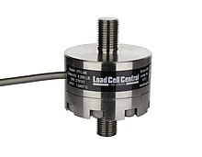
Canister load cell
- S-type load cell: S-shaped spring element; can be used in both compression and tension.
S-type load cell
- Wire rope clamps: an assembly attached to a wire rope and measures its tension; commonly used in crane and hoist applications.
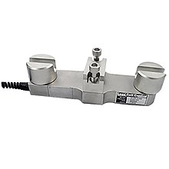
Wire rope clamp- on load cell
- Tension link load cell: often used in crane and hoist weighing systems. Measures tension force only.

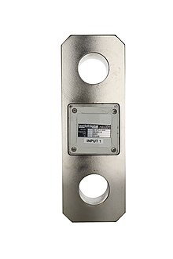
Tension link load cell
- Load pin: replaces pulleys and shivs, typically on cranes.
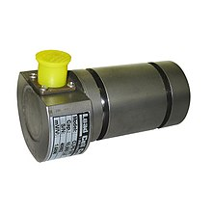

Pneumatic and hydraulic are other type of load cells
1. Pneumatic Load Cells
Let’s begin by looking at how a pneumatic load cell works.
Since it is pneumatic, we know that it will deal with air pressure. A pneumatic load cell consists of an elastic diaphragm which is attached to a platform surface where the weight will be measured.
There will be an air regulator that will limit the flow of air pressure to the system and a pressure gauge. Thus, when an object is placed on a pneumatic load cell it uses pressurized air or gas to balance out the weight of the object.
The air required to balance out the weight will determine how heavy the object weights. The pressure gauge can convert the air pressure reading into an electrical signal.
2. Hydraulic Load Cells
Next, let’s talk about a hydraulic load cell.
The word hydraulic should let us know that this sensor will work by using fluid, whether water or oil.
These load cells are similar to pneumatic load cells but instead of air, they use the pressurized liquid.
Hydraulic load cells are consisting of:
– An elastic diaphragm
– A piston with a loading platform on top of the diaphragm
– Oil or water that will be inside the piston
– A bourdon tube pressure gauge
When a load is placed on the loading platform the piston applies pressure to the liquid contained inside it. The pressure increase of the liquid is proportional to the applied force or weight.
After calibrating the pressure, you can accurately measure the force or weight applied to the hydraulic load cell.
The pressure reading can be read as an analog gauge or it can be converted into an electric signal from a pressure sensor.

BALANCES
ANALYTICAL
Analytical balances are highly sensitive lab instruments designed to accurately measure mass. Their readability has a range between 0.1mg - 0.01mg. Analytical balances have a draft shield or weighing chamber to prevent the very small samples from being affected by air currents. They're meant to detect very fine increments, so the slightest vibrations or breeze can impact the results. As such, analytical balances should be used in a dedicated room with as few disturbances as possible. Analytical balances need to be monitored carefully and calibrated frequently. Most analytical balances have both automatic internal motorized calibration and calibration with external weights. You can get calibration weight sets here.
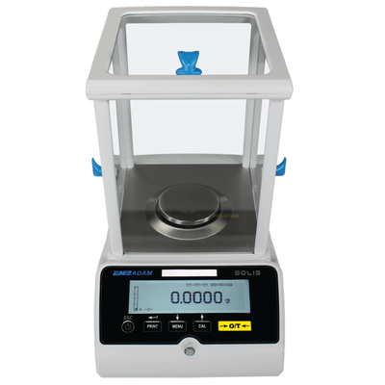

What makes analytical balances different from other balances?
Analytical balances are designed for very precise measurements of very small samples. Precision balances usually have a higher capacity than analytical balances do and typically deliver results of 0.1g, 0.01g or 1mg. Analytical balances have finer readability, are much more sensitive to changes, and can detect smaller variations in mass. Precision balances have more variety in body style and options, but they do not offer readabilities greater than three decimal places. For acute measurements in labs, analytical balances are the right choice.

BEAM BALANCE
The beam balance is a device used for the determination of the mass of a body under gravitation.
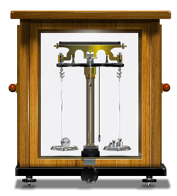
It consists of a beam supported at the centre by an agate knife edge resting on a support moving inside a vertical pillar. The beam carries a light pointer which moves over a scale. There are two stirrups at the ends of the beam which carries two scale pans of equal masses along with adjusting nuts. These can be adjusted to make the pointer oscillate within the scale when the balance is raised. The balance is mounted on a platform provided with three leveling screws which make the pillar vertical. There is a plumb line which shows whether the pillar is vertical or not. The balance is enclosed in a glass case in order to avoid disturbances due to air.

