IIC
You all are advised to go through previously taught units first before starting next topics.
So we left on last topic LVDT we will start from here you all will go through following topics in this file.
- LVDT
- Strain gauge unbounded type

LVDT
A linear variable differential transformer (LVDT) is measuring device that converts linear displacement into an electrical signal through the principle of mutual induction. Its design and operation are relatively simple, providing extremely high resolution in a device suitable for a wide range of applications and environments.
The main components of an LVDT are a transformer and a core. The transformer consists of three coils — a primary and two secondaries (S1 and S2) — wound on a hollow form, which is typically made of glass-reinforced polymer. The coils are arranged such that the primary coil is located between the two secondary coils, which are symmetrical and wound in series but in opposite directions (referred to as series-opposed winding).
The core is made of magnetically permeable material and moves freely inside the bore of the transformer. A non-ferromagnetic shaft, or push rod, is coupled to the core and connects to the object being measured.
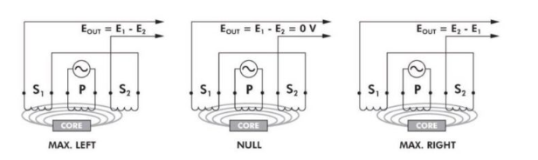
The induced voltage (E1) of the first secondary coil is in-phase with the primary voltage, indicating the direction of movement. Conversely, when the core moves to the other side of the transformer, the induced voltage (E2) of that secondary coil is out of phase with the primary voltage, indicating movement in the opposite direction.
The output of an LVDT is a direct and linear function of the input across its specified measuring range, although linearity falls off as the core reaches or exceeds the ends of its range. However, it is possible to use an LVDT beyond its specified range, in some cases, with a pre-defined table or polynomial function to compensate for the nonlinearity.
LVDT devices are extremely robust, since there is no physical contact, and therefore no friction or wear, between the moving core and the transformer bore. The transformer is typically encapsulated with epoxy to protect against contamination and moisture, and the housing can be made from a wide variety of materials — from stainless steel to nickel alloys or titanium.
Typical applications include tensile test and other material testing devices, load cells, and weighing devices. LVDTs are also used to measure displacement in hydraulic cylinders and actuators.

Strain gauge
Students before going through this topic please go through straing gauge types nad definition already discussed.
A Strain gauge (sometimes refered to as a Strain gage) is a sensor whose resistance varies with applied force; It converts force, pressure, tension, weight, etc., into a change in electrical resistance which can then be measured. When external forces are applied to a stationary object, stress and strain are the result.

Characteristics of strain gauges
The characteristics of strain gauges are as follows:
- They are highly precise and don’t get influenced due to temperature changes. However, if they do get affected by temperature changes, a thermistor is available for temperature corrections.
- They are ideal for long distance communication as the output is an electrical signal.
- Strain Gauges require easy maintenance and have a long operating life.
- The production of strain gauges is easy because of the simple operating principle and a small number of components.
- The strain gauges are suitable for long-term installation. However, they require certain precautions while installing.
- They are fully encapsulated for protection against handling and installation damage.
- The remote digital readout for strain gauges is also possible.

Unbounded strain gauges
These strain gauges are not directly bonded onto the surface of the structure under study. Hence they are termed as unbounded strain gauges.
Description of the Unbonded Strain gauges:
The arrangement of an unbonded strain gauges consists of the following. Two frames P and Q carrying rigidly fixed insulated pins as shown in diagram. these two frames can move relative with respect to each other and they are held together by a spring loaded mechanism. A fine wire resistance strain gauge is stretched around the insulated pins. The strain gauge is connected to a wheat stone bridge.

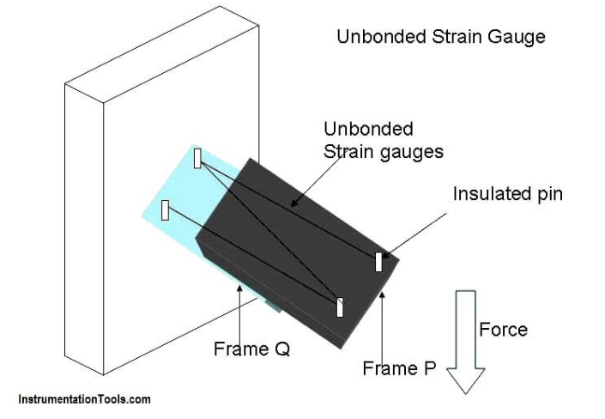
When a force is applied on the structure under study (frames P & Q), frames P moves relative to frame Q, and due to this strain gauge will change in length and cross section. That is, the strain gauge is strained.
This strain changes the resistance of the strain gauge and this change in resistance of the strain gauge is measured using a wheat stone bridge. This change in resistance when calibrated becomes a measure of the applied force and change in dimensions of the structure under study.

Application of Unbonded strain gauge:Unbonded strain gauge is used in places where the gauge is to be detached and used again and again.
unbonded strain gauges are used in force, pressure and acceleration measurement.

Next you will get study material for the following topics:
1)Force measuring devices
2)Humidity measurement
3)Level measurement
4) Ph meter

